Day 1 Student Lab Guide
Azure Fundamentals & App Service Lab Using Student-Owned Azure Accounts
Now with annotated portal screenshots and expanded step-by-step explanations
💰 Cost & Safety Note
Students will use their own Azure accounts/subscriptions. Azure may require a valid payment method.
Free/trial credits, service availability and UI screens may vary by account, region and Microsoft policy.
Students must delete lab resources at the end of the session to avoid unexpected charges.

1. Lab Overview
This guide is designed for Day 1 of the Cloud-Data-GenAI learning path. Students will create and validate basic Azure resources using their own Azure account. The lab builds cloud foundation skills before later modules such as networking, storage, DevOps, Databricks, observability, Power BI and GenAI.
📘 Explanation
Why start with App Service? Azure App Service is a fully managed Platform-as-a-Service (PaaS) for hosting web apps, REST APIs and mobile backends. It removes the need to patch operating systems or manage virtual machines, so it is the fastest way to see 'code to running cloud app' in a single session.
Everything you build today lives inside one Resource Group, which makes it easy to review what you created and to delete everything in one action at the end of class.

2. Learning Objectives
By the end of Day 1 you will be able to:
☐ Explain cloud computing and Azure fundamentals
☐ Create or validate access to an Azure account and subscription
☐ Create a resource group
☐ Use Azure Portal and Azure Cloud Shell
☐ Create and test an Azure App Service web app
☐ Understand App Service Plan, scale up and scale out
☐ Enable and inspect Application Insights/Azure Monitor telemetry
☐ Use safe cleanup practices to avoid unnecessary cost

3. Day 1 Target Architecture
Every resource you create today nests inside your own subscription, and every lab resource nests inside a single resource group. Requests you make in the Portal or Cloud Shell are translated into calls against Azure Resource Manager (ARM), the control-plane API that every Azure client — Portal, CLI, PowerShell, Terraform — ultimately talks to.
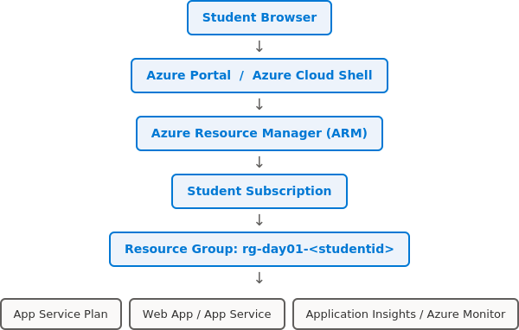
Figure 1. Request path from your browser down to the individual Day 1 resources.
💡 Concept
ARM is the reason 'Portal vs CLI' is a false choice: both are just different front-ends issuing the same underlying REST calls, which is why a resource group you create in the Portal shows up instantly when you list groups from Cloud Shell.

4. Student-Owned Azure Account Setup
🎓 Trainer Positioning
Before starting the lab, explain that each student is responsible for their own account, subscription, billing alerts and cleanup. The trainer provides instructions but cannot manage individual billing or subscription limits.

4.1 Pre-Lab Checklist
☐ A working email account for Azure sign-in
☐ Mobile phone available for verification/MFA
☐ Valid payment method if Azure requires it
☐ Browser: Microsoft Edge or Google Chrome
☐ Stable internet connection
☐ Ability to access portal.azure.com
☐ Permission to install Azure CLI locally if doing optional local CLI practice
☐ Understanding that all lab resources must be deleted after class

Step 1 — Sign in or Create Azure Account
Open the Azure portal in a browser, sign in with an existing Microsoft/Azure account, or create a new one if you don't have one yet. Complete identity verification, MFA and payment-method steps if Azure prompts for them — these are one-time account setup steps, not part of the lab resources you'll clean up later.
- Open portal.azure.com in Edge or Chrome.
- Sign in using an existing Microsoft/Azure account, or select 'Create one!' if you need a new account.
- Complete identity verification, MFA enrolment and payment-method entry if Azure requests them.
- After sign-in, confirm you land on the Azure Portal home page shown below.
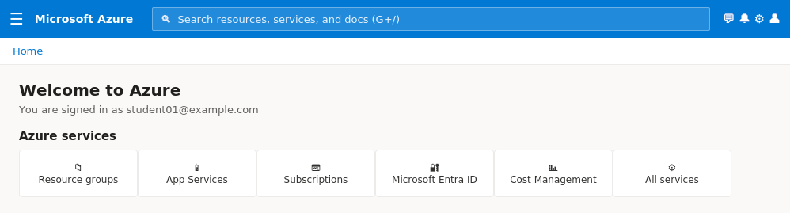
Figure 2. Azure Portal home page immediately after a successful sign-in. The service tiles let you jump straight to Resource groups, App Services and Subscriptions.
✅ Validation
You should be able to access the Azure Portal home page and search for services such as Resource Groups, App Services and Subscriptions.
🛠️ Troubleshooting
If the portal is blocked by organization policy or MFA fails, use a personal account or resolve account verification before continuing.

Step 2 — Confirm Subscription Access
A subscription is the billing and access boundary in Azure — every resource you create must belong to exactly one subscription, and quota, spending limits and role-based access are all scoped at this level. Signing in proves your identity; having an active subscription proves you're allowed to actually deploy resources.
- In the Azure Portal search bar, search for Subscriptions.
- Open Subscriptions and check whether at least one active subscription is visible.
- If none is active, activate a free/trial/pay-as-you-go subscription according to your account's eligibility.
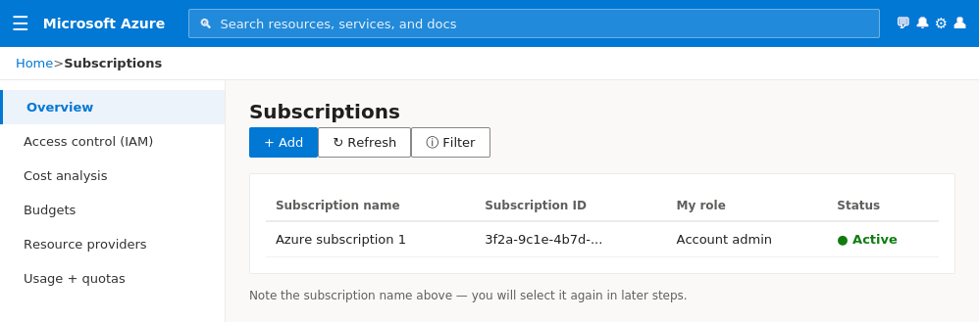
Figure 3. The Subscriptions blade. Write down the exact subscription name shown here — you'll pick it again when creating every resource today.
✅ Validation
At least one active subscription should be visible. Note the subscription name for later steps.
🛠️ Troubleshooting
If you see "No subscriptions found", your account can sign in but cannot create Azure resources yet.

Step 3 — Set Spending Awareness
Because this is your own account, nobody else is watching the meter. A budget alert costs nothing to set up and can email you before charges accumulate, which is the cheapest insurance policy you'll configure all day.
- Open Cost Management + Billing from the portal.
- Review the cost management options available for your subscription.
- Where available, create a budget or cost alert for training usage.
- Do not deploy production-size or expensive resources for this course.
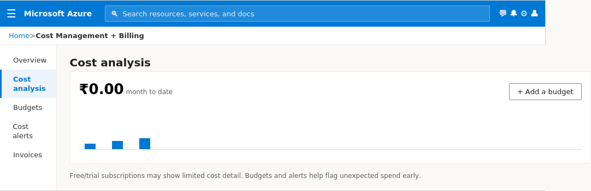
Figure 4. Cost analysis blade showing month-to-date spend and the 'Add a budget' action.
✅ Validation
Students should understand where to check subscription cost and billing details.
🛠️ Troubleshooting
Some free/trial/student subscriptions may have limited budget alert options. At minimum, students should know how to inspect cost and delete resources.

5. Naming Convention and Region
Consistent naming is what lets you tell your resources apart from everyone else's in a shared training subscription, and it's what will let you find and delete the right things quickly at cleanup time. Prefixes like rg-, asp- and appi- also match Microsoft's own Cloud Adoption Framework abbreviations, so the habit carries over directly to real projects.
Resource | Naming Format | Example
Resource Group | rg-day01-<studentid> | rg-day01-srini01
App Service Plan | asp-day01-<studentid> | asp-day01-srini01
Web App | app-day01-<studentid>-<unique> | app-day01-srini01-1025
Application Insights | appi-day01-<studentid> | appi-day01-srini01

Choose one region supported by your subscription. For India-based training, students may try Central India or South India if available. If a service is not available in the selected region, choose another trainer-approved region.

6. Lab 1 — Azure Portal Navigation

Step 1 — Explore Core Portal Areas
Spending five minutes getting comfortable with the layout below pays off for the rest of the day — every remaining lab is a variation of 'search for a service, open its blade, use the left-hand menu inside that blade.'
- Open the Azure Portal.
- Identify Home, Dashboard, Resource Groups, Subscriptions, Microsoft Entra ID, Azure Cloud Shell, Search, Notifications and Settings.
- Use the search bar to locate Resource Groups, App Services, Storage Accounts, Virtual Machines, Azure Monitor and Cost Management.
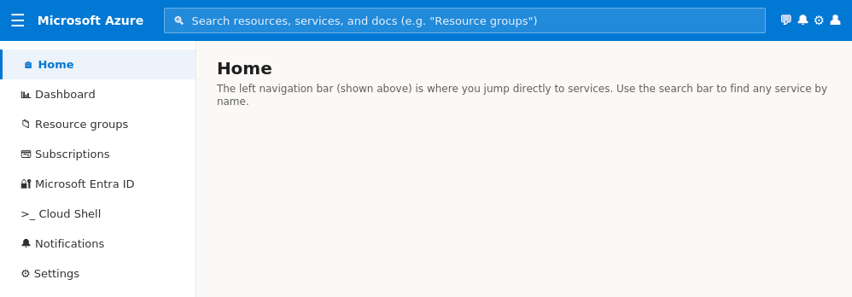
Figure 5. The Portal's left navigation bar — your starting point for jumping to any Azure service by name.
✅ Validation
Students should be able to locate Azure services using the portal search bar.

7. Lab 2 — Create a Resource Group
💡 Concept
A resource group is a logical container — it has no cost of its own, and deleting it deletes every resource inside it in one action. Grouping by 'day of training' rather than by resource type is what makes today's cleanup a single click instead of hunting down each resource individually.

Step 1 — Create Resource Group from Portal
- Open Resource Groups.
- Click Create.
- Choose your active subscription.
- Enter the resource group name using rg-day01-<studentid>.
- Choose the approved region.
- Click Review + Create and then Create.
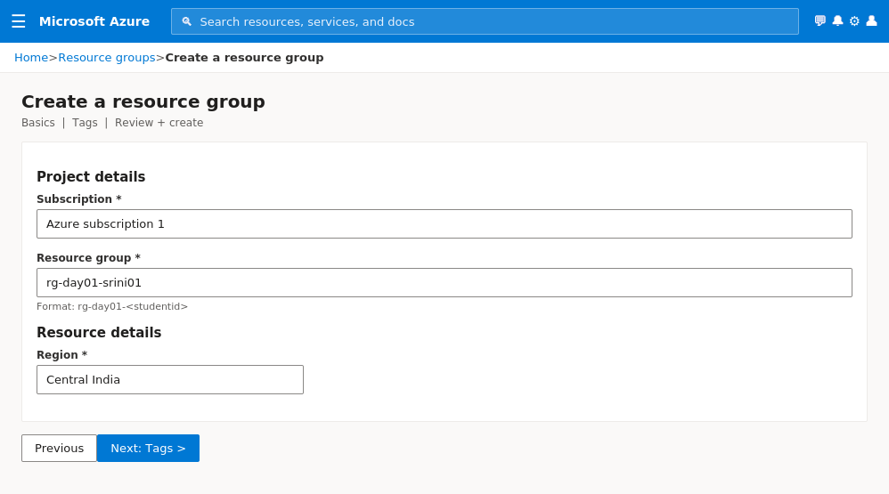
Figure 6. The Create a resource group form with Subscription, Resource group name and Region filled in.
✅ Validation
The Resource Group should be visible in the Resource Groups list.

Step 2 — Add Tags
Tags are key/value metadata attached to a resource or resource group. They don't change how a resource behaves, but they're what lets a trainer or a finance team filter a cost report by 'show me only the Training environment' across every student's subscription.
- Open the newly created resource group.
- Select Tags.
- Add Environment = Training, Course = CloudDataGenAI, Day = Day01, Owner = your name or student ID.
- Save the tags.
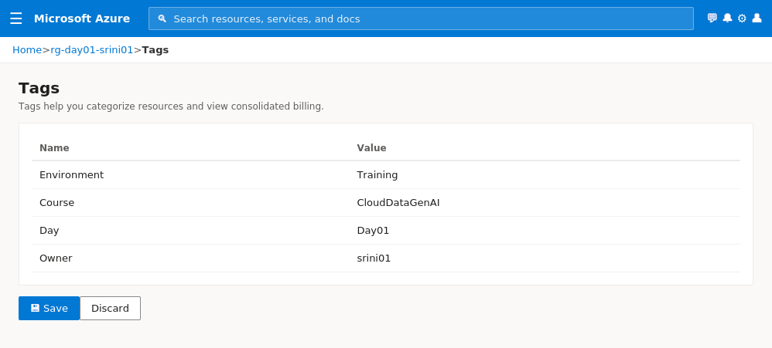
Figure 7. The Tags blade with the four Day 1 tags entered.
✅ Validation
Tags should be visible on the Resource Group.

8. Lab 3 — Azure Cloud Shell and CLI Basics
Cloud Shell is a browser-based terminal with the Azure CLI, Azure PowerShell and common tools pre-installed and pre-authenticated to your account — there is nothing to install locally, which is why it's the fastest way to run your first CLI commands.

Step 1 — Open Cloud Shell
- Click the Cloud Shell icon in the Azure Portal.
- Choose Bash.
- If prompted, create/select storage for Cloud Shell. For student accounts, follow the on-screen options and use the lowest-cost/simple default options.
✅ Validation
A Bash command prompt should open inside the portal.
🛠️ Troubleshooting
If Cloud Shell storage creation fails, continue with Portal labs and try Azure CLI locally later.

Step 2 — Check Account Context
These two commands confirm the CLI is authenticated as you and pointed at the same subscription you used in the Portal — a quick sanity check before you start creating resources from the command line.
az account show --output table
az group list --output table
✅ Validation
The active subscription should be displayed. Your new resource group should appear in the group list.

Step 3 — List Resources in Your Group
az resource list --resource-group rg-day01-<studentid> --output table
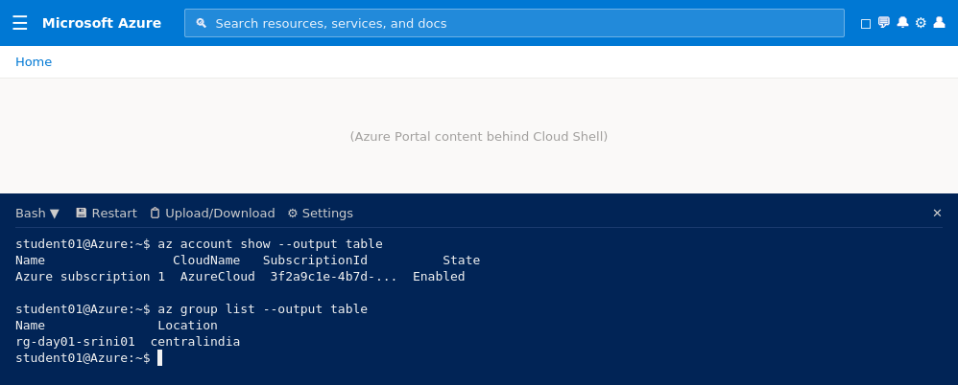
Figure 8. Cloud Shell open at the bottom of the Portal, running az account show and az group list.
✅ Validation
At this point, the group may have no resources except metadata. That is expected before App Service creation.

9. Lab 4 — Create Azure App Service Web App

Step 1 — Start Web App Creation
- In the Azure Portal, search for App Services.
- Click Create and choose Web App.
- Select your active subscription.
- Select the Day 1 resource group.

Step 2 — Configure Basic Web App Settings
The Web App name becomes part of a public URL (<name>.azurewebsites.net), so it must be unique across every App Service in Azure, not just within your subscription — that's why the naming convention appends a short unique suffix.
- Name: app-day01-<studentid>-<unique>. The name must be globally unique.
- Publish: Code.
- Runtime stack: choose a simple runtime available in your account such as Node.js, Python or .NET.
- Operating System: Linux or Windows as per selected runtime and trainer guidance.
- Region: same region as the Resource Group where possible.
✅ Validation
The form should show valid values without validation errors.

Step 3 — Configure App Service Plan
The App Service Plan is the actual compute (CPU, memory, instance count) that hosts your Web App — the Web App itself is just the application layer sitting on top of it. One plan can host multiple web apps, which is why it's created and named separately.
- Create a new App Service Plan named asp-day01-<studentid>.
- Select a low-cost/free/dev-test compatible pricing tier where available in your subscription.
- Avoid production or premium tiers for this training lab.
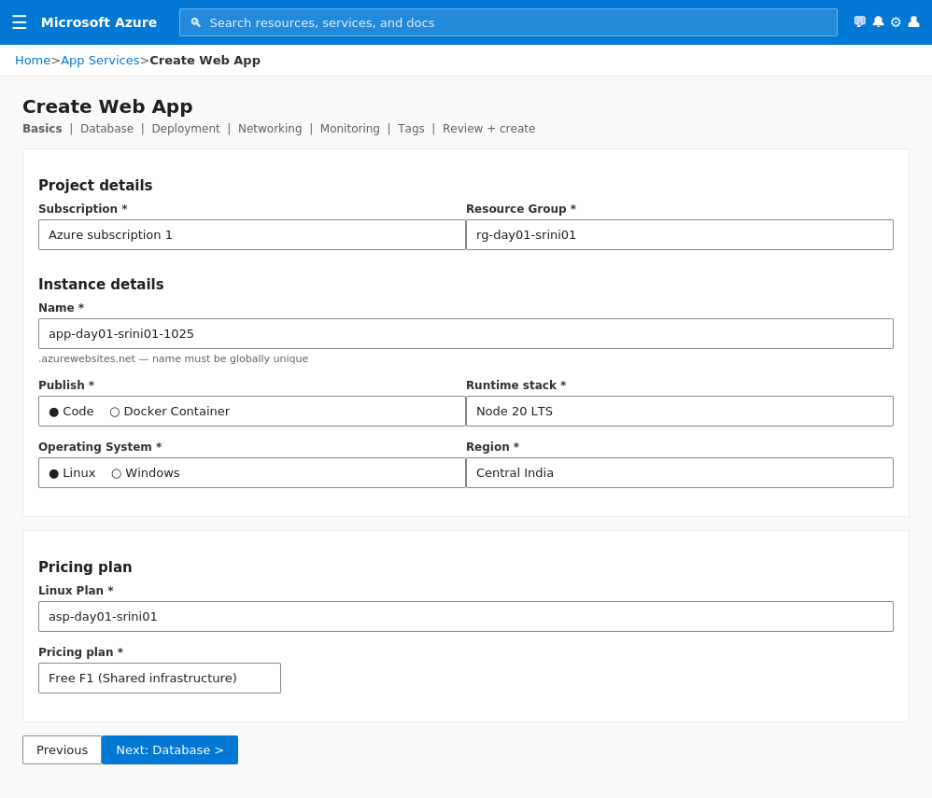
Figure 9. The Create Web App form: project details, instance details (name, runtime, OS, region) and the linked App Service Plan / pricing tier.
✅ Validation
The App Service Plan should be associated with the Web App.
🛠️ Troubleshooting
If a free/dev tier is unavailable, select the lowest trainer-approved tier and delete it immediately after the lab.

Step 4 — Enable Monitoring
- If the Application Insights option is shown during creation, enable it.
- Name it appi-day01-<studentid>.
- Use the same region where available.
✅ Validation
Application Insights should be linked to the Web App if supported by your selected runtime/configuration.

Step 5 — Review and Create
- Click Review + Create.
- Review the estimated configuration carefully.
- Click Create.
- Wait until deployment succeeds.
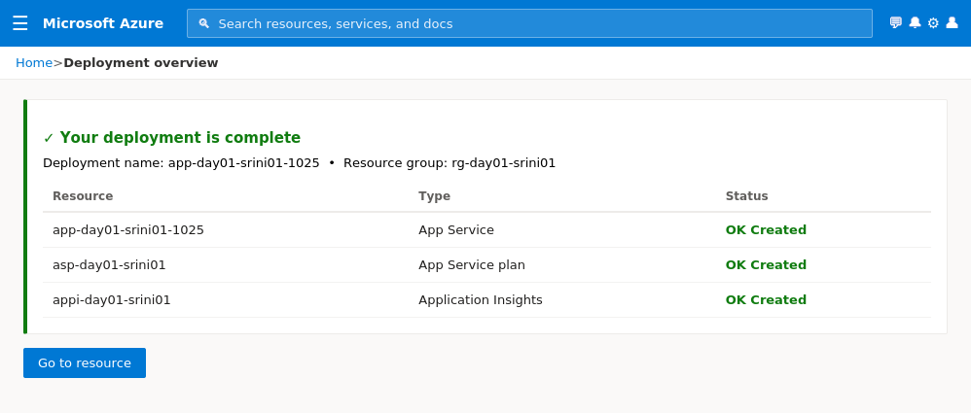
Figure 10. The deployment overview once all three resources — Web App, App Service Plan and Application Insights — have finished provisioning.
✅ Validation
Deployment should show Successful. Open the created Web App from the deployment page.

10. Lab 5 — Test the Web App

Step 1 — Open Default Domain
Every App Service gets a free *.azurewebsites.net domain and a managed TLS certificate the moment it's created — no DNS or certificate configuration required for this lab.
- Open the App Service resource.
- On Overview, copy or click the Default Domain/URL.
- Open it in a new browser tab.
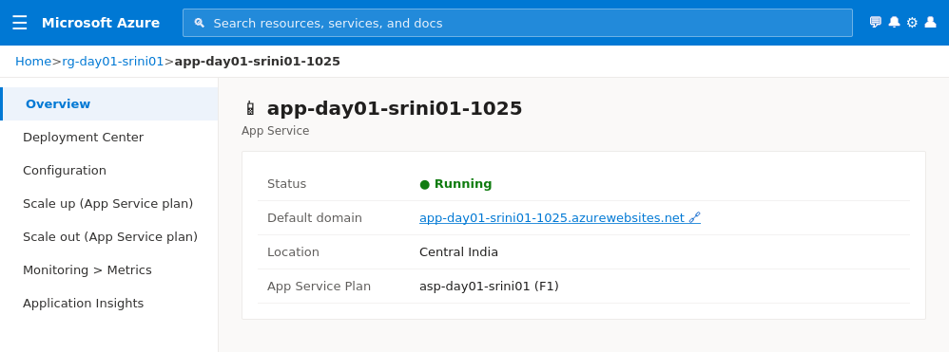
Figure 11. App Service Overview blade. The Default domain link is what you open in a new tab.
✅ Validation
You should see the default app page or sample runtime landing page.

Step 2 — Generate Basic Traffic
You're generating this traffic on purpose: Application Insights and Azure Monitor have nothing to chart until real HTTP requests hit the app, so a few manual refreshes now is what makes Lab 7's metrics meaningful.
- Refresh the page 5 to 10 times.
- Open the URL from another browser tab.
- Keep the app open for later monitoring exercises.
✅ Validation
The web app should continue responding successfully.

11. Lab 6 — Understand Scale Up and Scale Out
💡 Concept
Scale up means increasing the size/capacity of the hosting plan. Scale out means increasing the number of running instances. App Service plan tier determines which scaling options are available.
Rule of thumb: scale up when a single request is slow (not enough CPU/memory per instance); scale out when you have many concurrent users (need more instances sharing the load). Free and Basic tiers cap scale-out at 1 instance and disable autoscale — that's a deliberate cost guardrail, not a bug.

Step 1 — Explore Scale Up
- Open the App Service Plan or Web App scale settings.
- Open Scale up.
- Observe the available tiers. Do not change to a paid higher tier unless the trainer explicitly instructs you.
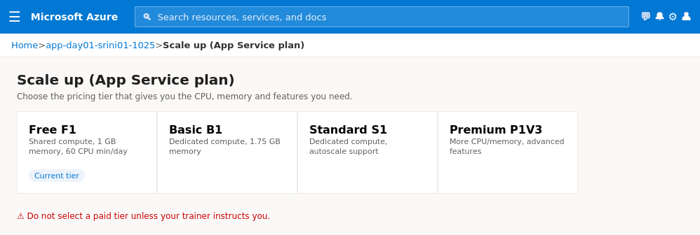
Figure 12. Scale up (App Service plan) blade comparing Free, Basic, Standard and Premium tiers.
✅ Validation
Students should be able to explain that scale up changes compute capacity.

Step 2 — Explore Scale Out
- Open Scale out where available.
- Observe manual and autoscale options.
- Do not enable autoscale if your subscription/tier does not support it or if it may add cost.
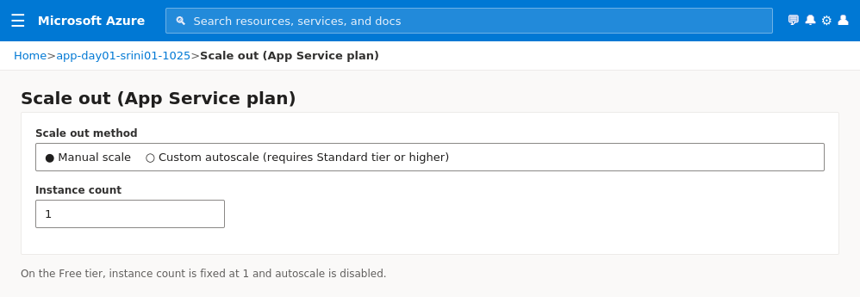
Figure 13. Scale out (App Service plan) blade. On the Free tier, instance count is fixed at 1 and autoscale is unavailable.
✅ Validation
Students should be able to explain that scale out changes instance count.

12. Lab 7 — Application Insights and Azure Monitor

Step 1 — Open Application Insights
Application Insights is an Azure Monitor feature that instruments your app to capture requests, dependencies, exceptions and performance counters automatically, without you writing logging code.
- From the App Service, open Application Insights or search for the Application Insights resource.
- Review overview metrics such as requests, failures and response time if data is available.
- It can take a few minutes for telemetry to appear.
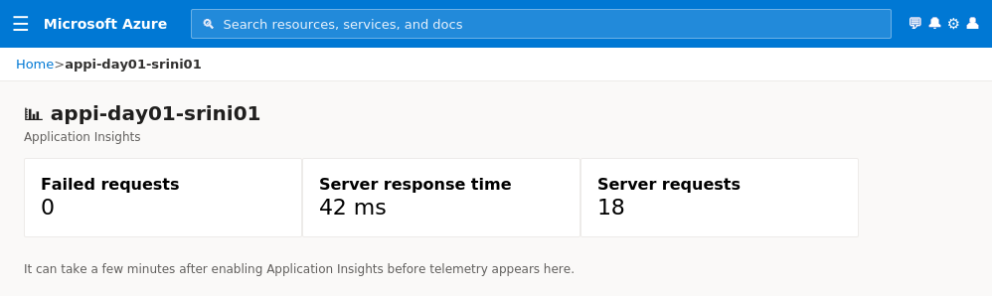
Figure 14. Application Insights overview showing failed requests, response time and server request counts.
✅ Validation
Requests should eventually appear after page refreshes if Application Insights was enabled.

Step 2 — View Metrics
- Open App Service > Monitoring > Metrics.
- Select available metrics such as Requests, Response Time, CPU Time or HTTP server errors.
- Change time range to Last 30 minutes.
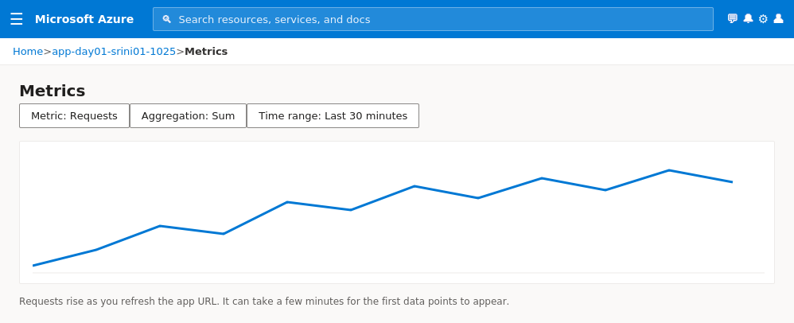
Figure 15. Metrics chart plotting Requests over the last 30 minutes — the line climbs as you refresh the app URL.
✅ Validation
A chart should display if metrics are available.

Step 3 — Activity Log
The Activity Log is an audit trail of control-plane operations (create, update, delete) on a resource group — different from Application Insights, which tracks what happens *inside* the running app.
- Open the Resource Group.
- Open Activity Log.
- Observe create/update events for the resources you created.
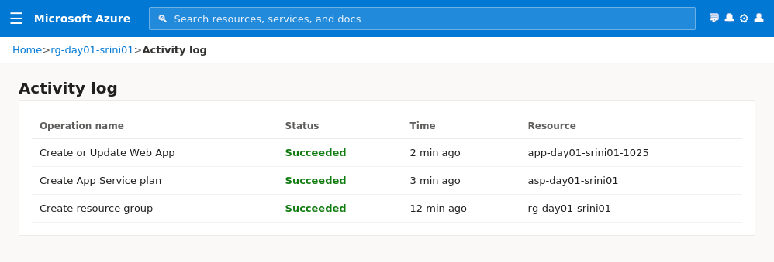
Figure 16. Activity Log listing the Create operations for the Web App, App Service Plan and Resource Group.
✅ Validation
Activity Log should show management operations for the Resource Group.

13. Lab 8 — Optional CLI Creation and Verification
➕ Optional
Use this lab only if students are comfortable with CLI. Portal-first execution is sufficient for Day 1.

Create a Test Resource Group with CLI
az group create --name rg-day01-cli-<studentid> --location centralindia
✅ Validation
The CLI-created group should appear in the Azure Portal.

Delete the CLI Test Resource Group
az group delete --name rg-day01-cli-<studentid> --yes
✅ Validation
The CLI-created group should be removed after deletion completes.

14. Common Troubleshooting
Issue | Suggested Fix
No active subscription | Activate a subscription or use another account. Portal sign-in alone is not enough to create resources.
App name not available | Use a more unique Web App name by adding numbers or initials.
Region unavailable | Choose another trainer-approved region.
Resource creation blocked | Check subscription status, spending limits, policy restrictions or resource provider registration.
Application Insights has no data | Wait a few minutes, generate traffic and confirm it is enabled.
Cloud Shell does not open | Use Portal-only steps or install Azure CLI locally if permitted.
Costs are increasing | Stop/delete the App Service or delete the whole Day 1 Resource Group.

15. Day 1 Student Challenge
Complete this challenge without step-by-step trainer support.
☐ Create a new Resource Group named rg-day01-challenge-<studentid>
☐ Create an App Service Plan
☐ Create a Web App
☐ Open the Web App URL successfully
☐ Add tags: Environment, Course, Day and Owner
☐ Open Metrics and observe at least one metric chart
☐ Explain scale up vs scale out to the trainer
☐ Delete the challenge Resource Group after validation

16. Cleanup — Mandatory
💰 Cost & Safety Note
Cleanup is mandatory when using your own Azure account. The safest Day 1 cleanup is to delete the entire Resource Group created for the lab, after confirming it contains only lab resources.

Portal Cleanup
- Open Resource Groups.
- Select rg-day01-<studentid>.
- Click Delete Resource Group.
- Type the resource group name for confirmation.
- Delete only your own Day 1 training group.
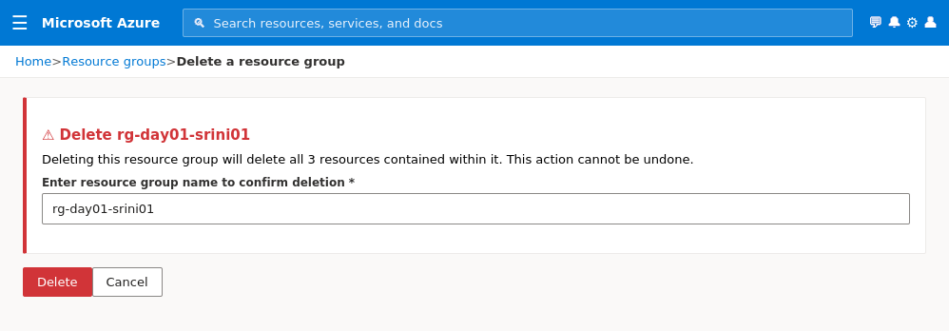
Figure 17. Delete confirmation dialog — typing the exact resource group name is a deliberate safeguard against deleting the wrong group.
✅ Validation
The Resource Group and all its contained resources should be deleted.

CLI Cleanup
az group delete --name rg-day01-<studentid> --yes
✅ Validation
Run az group list --output table to verify the group is removed.

17. Final Validation Checklist
☐ I created or verified my own Azure subscription access
☐ I created a Resource Group
☐ I used Azure Portal and Cloud Shell
☐ I created an Azure App Service Web App
☐ I understood the purpose of App Service Plan
☐ I opened the Web App URL
☐ I explored scale up and scale out settings
☐ I viewed Application Insights or Azure Monitor metrics
☐ I checked Activity Log
☐ I deleted all Day 1 lab resources

18. Quick Viva Questions
- What is cloud computing?
- Difference between IaaS, PaaS and SaaS?
- Why is App Service considered PaaS?
- What is a Resource Group?
- What is Azure Resource Manager?
- What is the difference between Azure Portal and Azure CLI?
- What is an Azure Region?
- What is an Availability Zone?
- What is an App Service Plan?
- Scale up vs scale out?
- Why do we use Application Insights?
- Why is cleanup important in student-owned accounts?

19. Trainer Closing Message for Students
Today you created and validated your own Azure learning environment. You used Azure Portal, Resource Groups, Cloud Shell, App Service, App Service Plan and monitoring basics. From Day 2 onward, we will build on this foundation with Azure networking and virtual machines.

